National Association Of Letter Carriers 4374
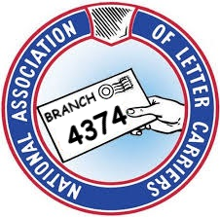
South Macomb Letter Carriers
Roseville Installation
Abusive Supervisor Incident Worksheet

Letter Carrier______________________________________________________Date________________

Supervisor's Name__________________________ Duty Station________________________________

Date of Incident _________________Time of Incident _______________

Location of Incident_____________________________________________________________________

Date and Name of Union Official Notified ___________________________________________________

Victim(s) of Incident ____________________________________________________________________

Witnesses to Incident ___________________________________________________________________

Description of Abusive Incident:

NATURE OF ABUSIVE EVENT (Check All That Apply)
□ | Demeaning _____________________________________________________________________
□ | Yelling _________________________________________________________________________
□ | Threats of Discipline or Discharge ___________________________________________________
□ | Profanity ______________________________________________________________________
□ | Physical Threats ________________________________________________________________
□ | Physical Gestures ________________________________________________________________
□ | Physical Contact _________________________________________________________________
□ | Other Specifics __________________________________________________________________

Signature _________________________________________________ Date_________________

