National Association Of Letter Carriers 4374 Roseville **Mutual Agreement to Extend Grievance Timelines**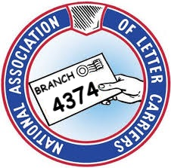

On 10/9/2024 The undersigned parties mutually agree to extend the time limits for the....

* Informal A Meeting To Be Held
* The continuance of the Informal A
* The appeal to Formal A
* The Formal A Meeting To Be Held
* The continuance of the Formal A Meeting
* The appeal to Step B

For the Following Grievance(s) RSVL-205, 220, 209, 208, 219, 215, 228, 222, 206, 95, 207 and 211-24 and any Formal A Appeal processed before the extension date.

To be extended until the following date: 11/1/2024

___________________________________ ___________________________________

Chief Steward Joshua Shrum Date Usps Designee Date